{{DATE}}

**{{CLIENT_NAME}}**

**{{ADDRESS}}**

**ATTENTION: {{CONTACT_PERSON}}**

Dear Sir/Madam,  
  
We take special pleasure in submitting our firm quotation for the KYOCERA DIGITAL COPIER TASKalfa 2020 as follows:

**BLACK ‘n WHITE COPY & PRINT, COLORED SCAN**

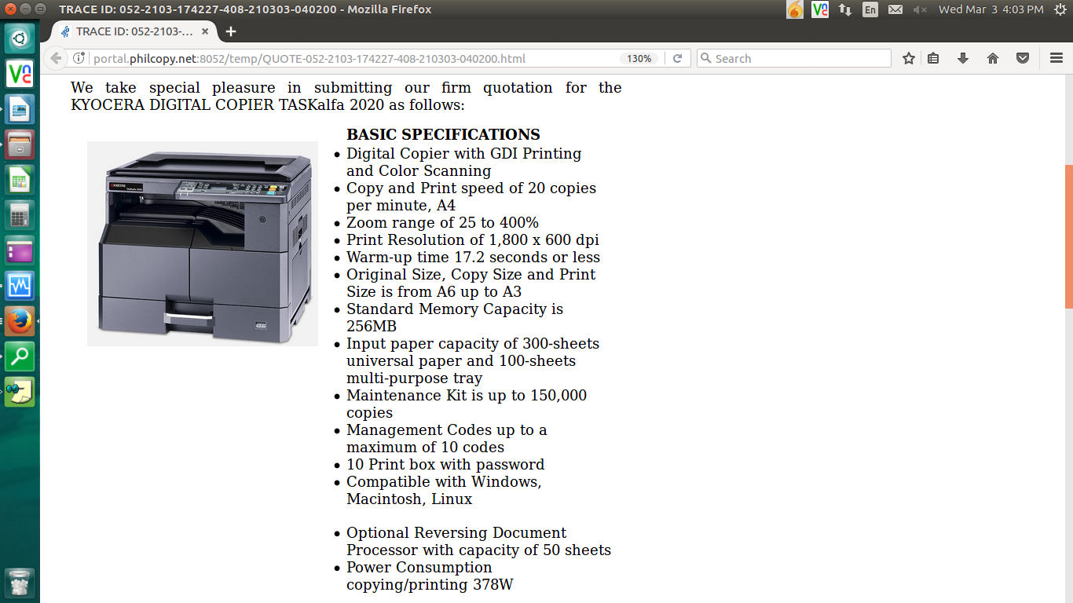

* **MACHINE PRICE (VAT INCLUSIVE)**

|  |  |  |
| --- | --- | --- |
| 1 unit of KYOCERA DIGITAL COPIER TASKalfa 2020 | Php | 63,000.00 |

**PROMO**

MACHINE ORIGINAL PRICE: Php 63,000.00

LESS PROMO DISCOUNT Php 12,600.00

**TOTAL DISCOUNTED AMOUNT Php 50,400.00 (Less 10% in COD=> Php 45,360.00)**

Php 4,200/MO. FOR 12 MONTHS (CREDIT CARD)

ANNIVERSARY PROMO SPECIAL

(METRO MANILA) ONLY Php 38,296.80(CASH)

* WITH FREE STARTER TONER OF UP TO 3,000 PAGES
* WITH A FREE USB SERIES CABLE
* WITH A FREE SOCKET ADAPTER

**OPTIONAL ACCESSORIES (NOT INCLUDED IN THE MACHINE PRICE)**

AUTO-FEEDER/ DOCUMENT PROCESSOR Php 25,425.00

STEEL TABLE/CABINET Php 6,700.00

3 YEARS SERVICE WARRANTY EXTENSION Php 6,600.00

* **PRICE OF CONSUMABLES (VAT EXCLUSIVE)**

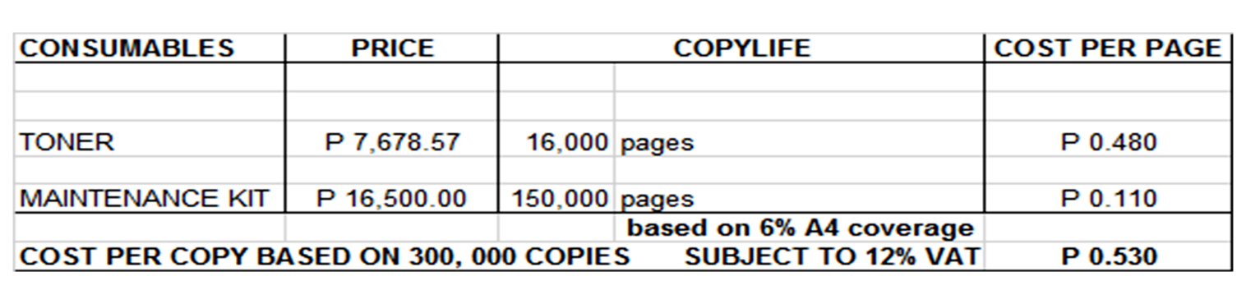

**Terms of Payment:** COD CASH/ 12 months Credit Card  
  
**VALIDITY:** Prices are subject to change without prior notice, please confirm with us prior to the finalization of the order.  
  
**WARRANTY:**   
  
KYOCERA DIGITAL PLAIN PAPER COPIERS are guaranteed spare parts replacement FREE OF CHARGE for ONE (1) year, or up to 150,000 copies/print/scan whichever comes first.  
  
Warranty for accessories and options is ONE (1) year from the date of delivery.  
  
We also assure prompt service whenever you need assistance. Repair service is FREE for TWO (2) years. Should our machine require prolonged service, we shall install a backup unit immediately for your convenience.  
  
Installation and Training of Personnel: Our expert service engineers install all our machines and they will be glad to train interested personnel on the detailed mechanics of the machine free of charge.

Moreover, the amount quoted above excludes the cost of any required tests or medical certifications such as, but not limited to Rapid tests, Antigen tests, and RT-PCR tests. The actual cost will be billed separately

We are looking forward to hearing from you soon. For any questions or concerns, please feel free to call us at 7618-0274.  
  
  
Very truly yours, Conforme:

**JAYPEE V. SONIEL __________________________________**  
SENIOR ACCOUNT EXECUTIVE II

09176240820 (Viber Ready)